Pythagorean Theorem

Definition
# Source: AI Source: Provided by: [Data Path: Persons Table -> ID Column: 1, Name_En Column: Motasem Essam] -> From: [ChatGPT] on [7/25/2026]
The Pythagorean Theorem is a fundamental theorem in geometry that describes the relationship between the three side lengths of a right triangle.
It states that:
The square of the length of the hypotenuse is equal to the sum of the squares of the lengths of the two legs.
For a right triangle with legs $a$ and $b$, and hypotenuse $c$:
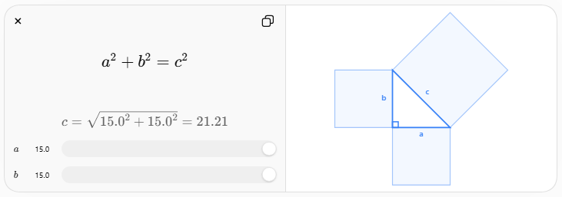
$$\boxed{a^{2}+b^{2}=c^{2}}$$
where:
- $a$ = length of one leg
- $b$ = length of the other leg
- $c$ = length of the hypotenuse

Purpose
# Source: AI Source: Provided by: [Data Path: Persons Table -> ID Column: 1, Name_En Column: Motasem Essam] -> From: [ChatGPT] on [7/25/2026]
The Pythagorean Theorem is used to:
- Find an unknown side of a right triangle.
- Calculate distances between points.
- Determine diagonal lengths.
- Solve geometric problems.
- Analyze right triangles.
- Support trigonometry.
- Calculate distances in coordinate geometry.
- Solve problems in engineering, architecture, surveying, and construction.

Right Triangle
# Source: AI Source: Provided by: [Data Path: Persons Table -> ID Column: 1, Name_En Column: Motasem Essam] -> From: [ChatGPT] on [7/25/2026]
A right triangle is a triangle containing one angle measuring exactly:
$$\boxed{{90}^{∘}}$$
The side opposite the ${90}^{∘}$angle is called the hypotenuse.
The other two sides are called the legs.
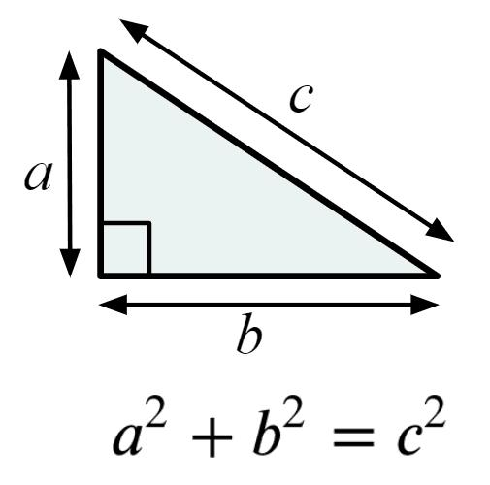
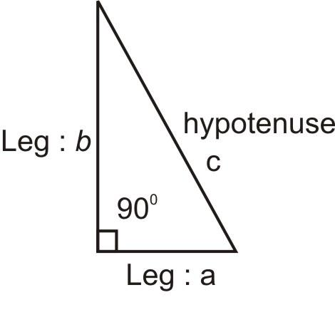
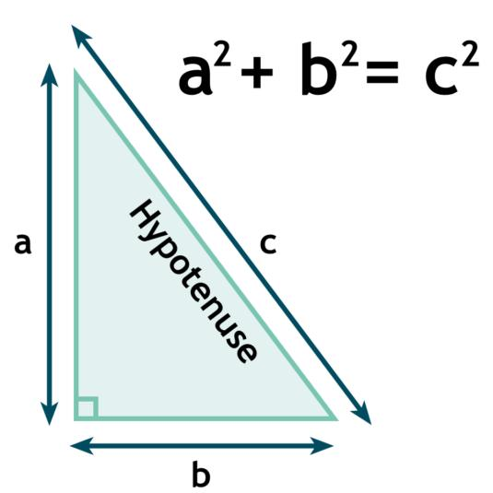
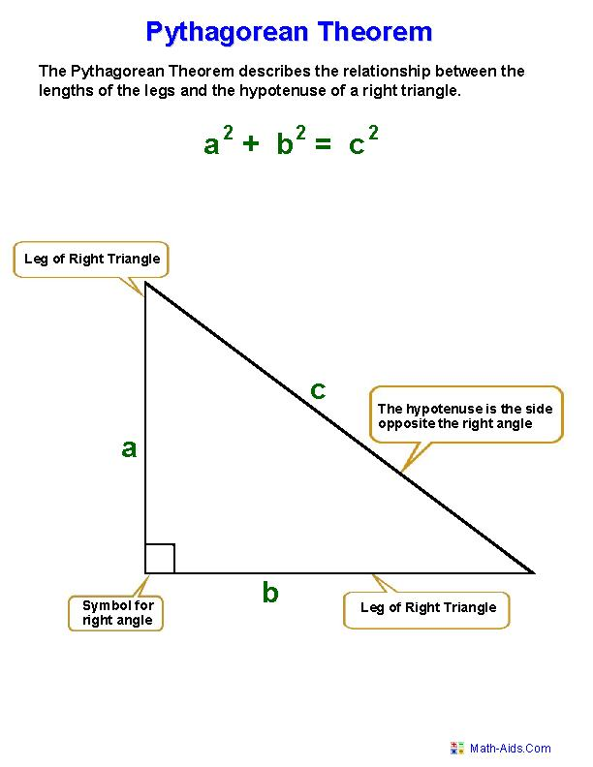
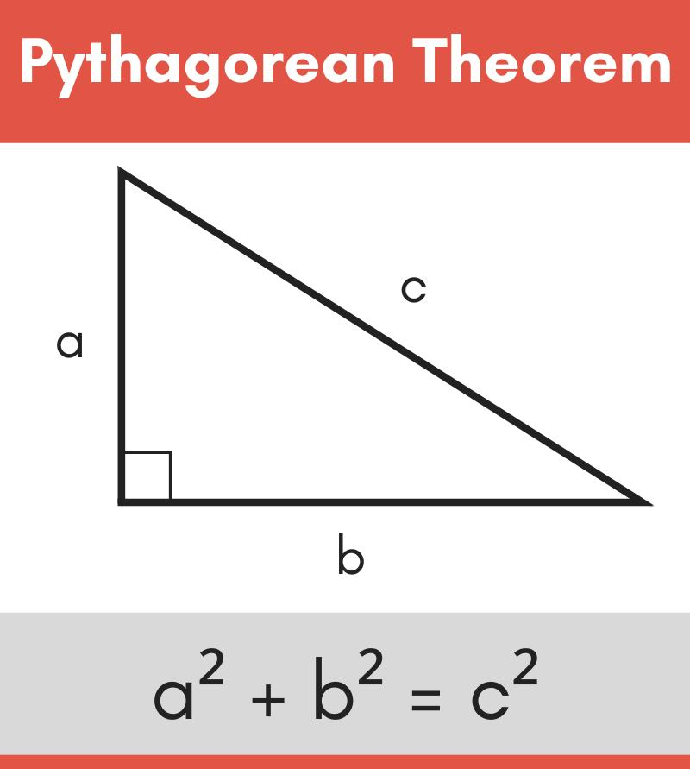

Hypotenuse
# Source: AI Source: Provided by: [Data Path: Persons Table -> ID Column: 1, Name_En Column: Motasem Essam] -> From: [ChatGPT] on [7/25/2026]
The hypotenuse is always:
- Opposite the right angle.
- The longest side of a right triangle.
If the legs are:
$$a, b$$
then the hypotenuse is:
$$c$$
and:
$$\boxed{c>a} \\ \boxed{c>b}$$

Mathematical Representation
# Source: AI Source: Provided by: [Data Path: Persons Table -> ID Column: 1, Name_En Column: Motasem Essam] -> From: [ChatGPT] on [7/25/2026]
The Pythagorean Theorem is:
$$\boxed{a^{2}+b^{2}=c^{2}}$$
This means:
$$\boxed{{\text{Leg}}^{2}+{\text{Leg}}^{2}={\text{Hypotenuse}}^{2}}$$
It applies only to right triangles.

Finding the Hypotenuse
# Source: AI Source: Provided by: [Data Path: Persons Table -> ID Column: 1, Name_En Column: Motasem Essam] -> From: [ChatGPT] on [7/25/2026]
If the two legs are known:
$$a=3 \\ b=4$$
then:
$$3^{2}+4^{2}=c^{2} \\ 9+16=c^{2} \\ 25=c^{2}$$
Therefore:
$$\boxed{c=5}$$
This gives the famous:
$$\boxed{3-4-5}$$
right triangle.
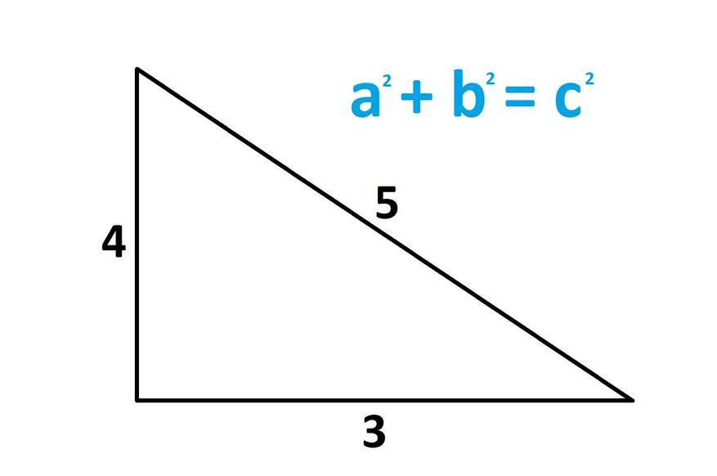
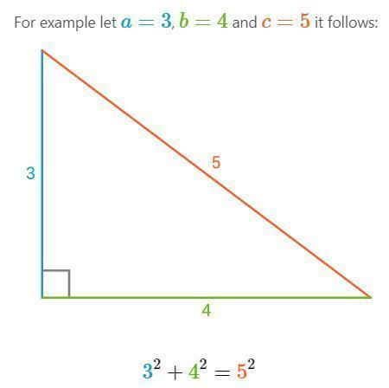
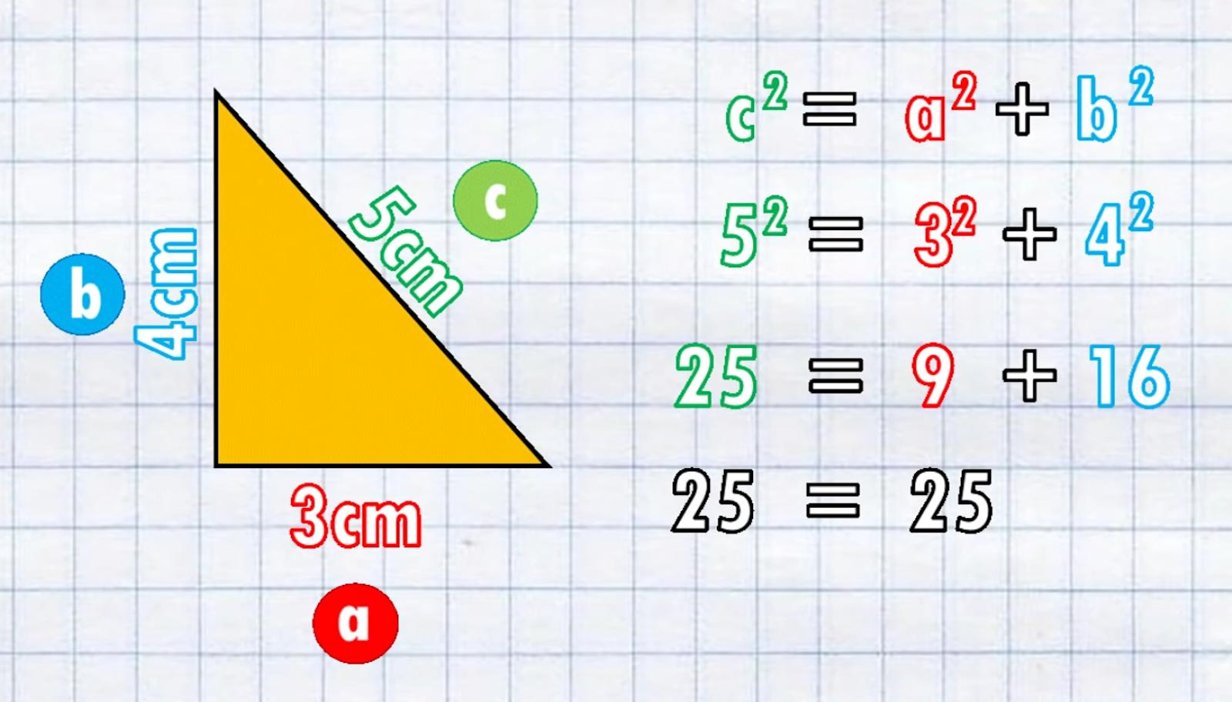
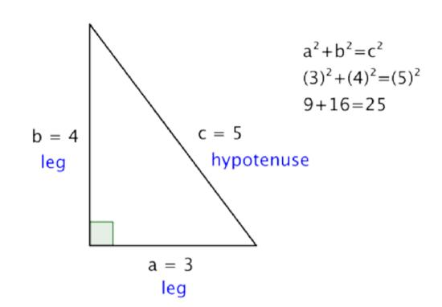
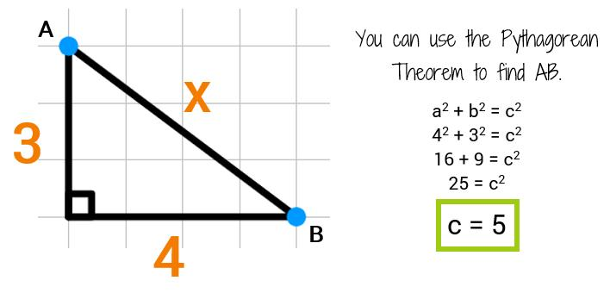

Finding a Missing Leg
# Source: AI Source: Provided by: [Data Path: Persons Table -> ID Column: 1, Name_En Column: Motasem Essam] -> From: [ChatGPT] on [7/25/2026]
The formula can be rearranged to find either leg.
Starting with:
$$a^{2}+b^{2}=c^{2}$$
To find $a$:
$$\boxed{a=\sqrt{c^{2}-b^{2}}}$$
To find $b$:
$$\boxed{b=\sqrt{c^{2}-a^{2}}}$$

Example — Finding a Leg
# Source: AI Source: Provided by: [Data Path: Persons Table -> ID Column: 1, Name_En Column: Motasem Essam] -> From: [ChatGPT] on [7/25/2026]
Suppose:
$$c=13$$
and:
$$b=5$$
Find $a$.
Using:
$$a=\sqrt{c^{2}-b^{2}}$$
we get:
$$a=\sqrt{{13}^{2}-5^{2}} \\ a=\sqrt{169-25} \\ a=\sqrt{144}$$
Therefore:
$$\boxed{a=12}$$
This produces the well-known:
$$\boxed{5-12-13}$$
right triangle.

Pythagorean Triples
# Source: AI Source: Provided by: [Data Path: Persons Table -> ID Column: 1, Name_En Column: Motasem Essam] -> From: [ChatGPT] on [7/25/2026]
A Pythagorean triple is a set of three positive integers satisfying:
$$a^{2}+b^{2}=c^{2}$$
Common examples include:
$$\boxed{3, 4, 5} \\ \boxed{5, 12, 13} \\ \boxed{8, 15, 17} \\ \boxed{7, 24, 25}$$
For example:
$$8^{2}+{15}^{2}={17}^{2} \\ 64+225=289 \\ 289=289$$
Therefore, $8,15,17$ form a right triangle.
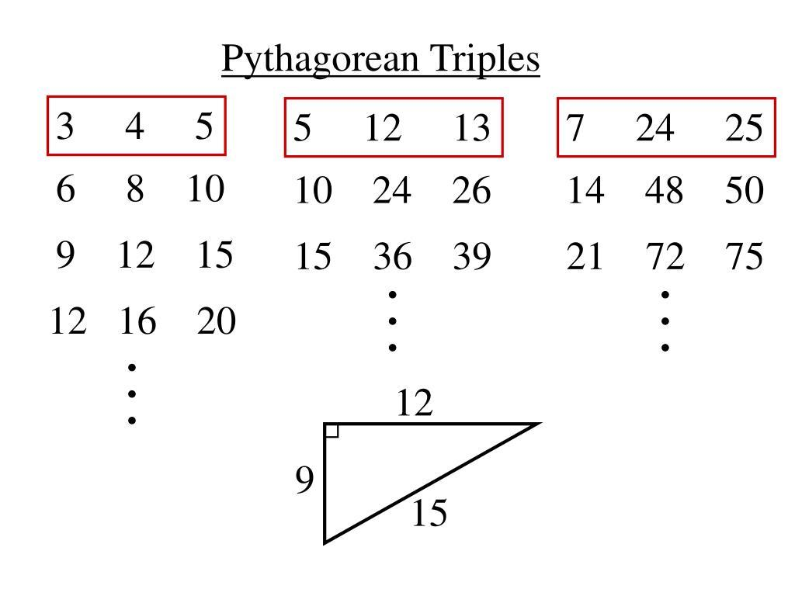
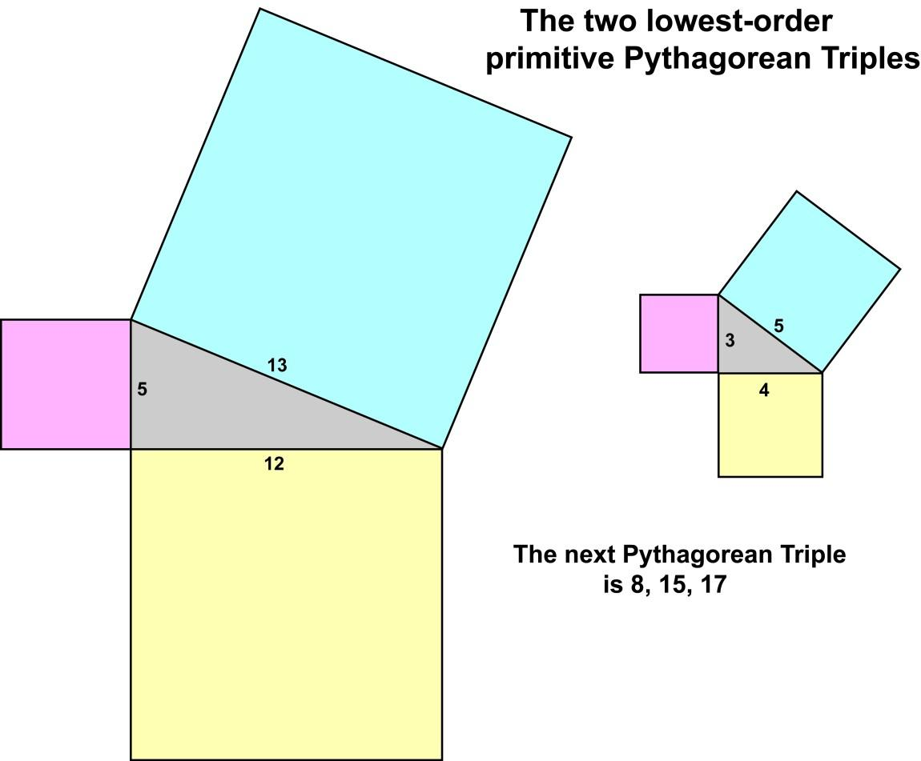
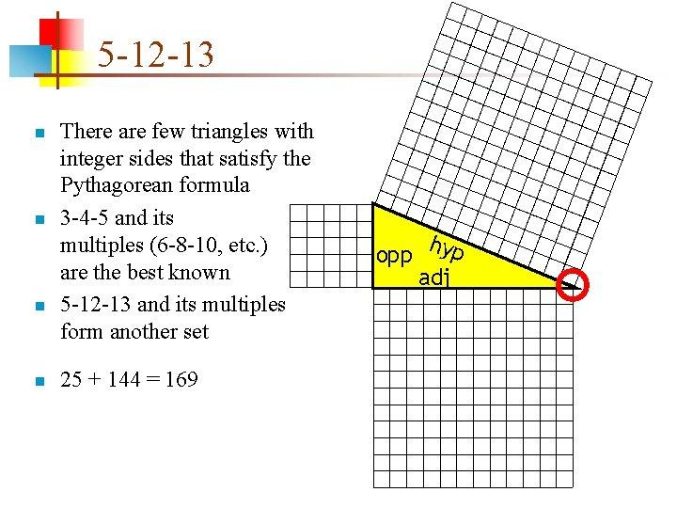
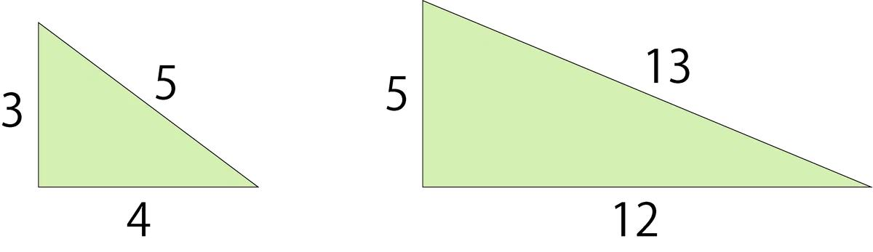

Converse of the Pythagorean Theorem
# Source: AI Source: Provided by: [Data Path: Persons Table -> ID Column: 1, Name_En Column: Motasem Essam] -> From: [ChatGPT] on [7/25/2026]
The converse can be used to determine whether a triangle is a right triangle.
If the longest side is $c$ and:
$$\boxed{a^{2}+b^{2}=c^{2}}$$
then the triangle is a right triangle.
Example
Suppose the sides are:
$$6, 8, 10$$
The longest side is $10$.
Check:
$$6^{2}+8^{2}={10}^{2} \\ 36+64=100 \\ 100=100$$
Therefore:
$$\boxed{\text{The triangle is a right triangle}}$$

Pythagorean Theorem and Triangle Inequality
# Source: AI Source: Provided by: [Data Path: Persons Table -> ID Column: 1, Name_En Column: Motasem Essam] -> From: [ChatGPT] on [7/25/2026]
These two theorems are related but different.
Triangle Inequality
For every proper triangle:
$$\boxed{a+b>c}$$
Pythagorean Theorem
For a right triangle:
$$\boxed{a^{2}+b^{2}=c^{2}}$$
The Triangle Inequality applies to all triangles, while the Pythagorean Theorem applies specifically to right triangles.

Pythagorean Theorem and Acute/Obtuse Triangles
# Source: AI Source: Provided by: [Data Path: Persons Table -> ID Column: 1, Name_En Column: Motasem Essam] -> From: [ChatGPT] on [7/25/2026]
The relationship between the squared sides can also classify a triangle.
Let $c$be the longest side.
Right Triangle
If:
$$\boxed{a^{2}+b^{2}=c^{2}}$$
then the triangle is right.
Acute Triangle
If:
$$\boxed{a^{2}+b^{2}>c^{2}}$$
then the triangle is acute.
Obtuse Triangle
If:
$$\boxed{a^{2}+b^{2}<c^{2}}$$
then the triangle is obtuse.
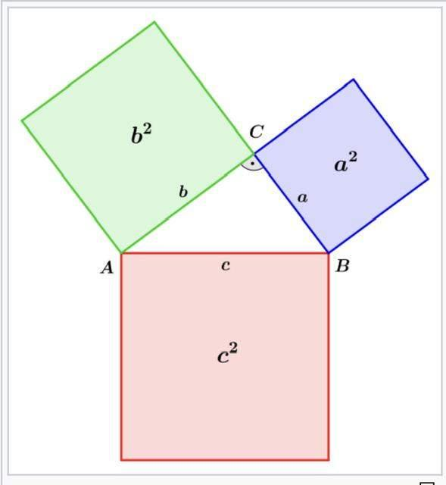
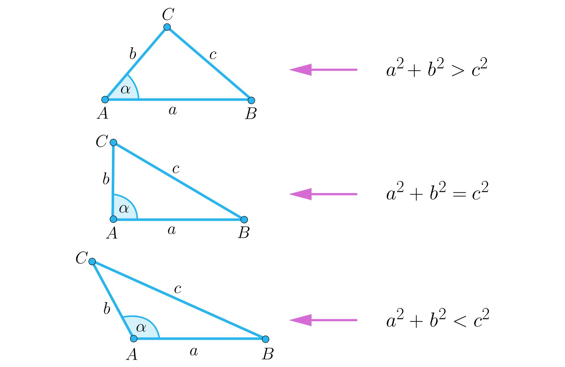
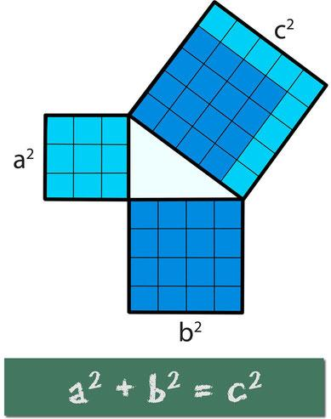
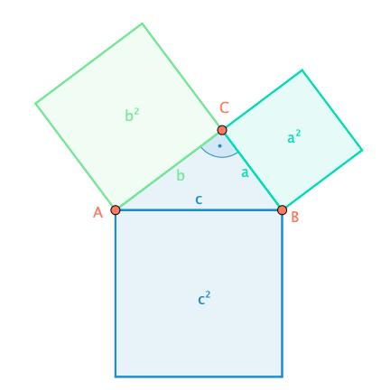

Diagonal of a Rectangle
# Source: AI Source: Provided by: [Data Path: Persons Table -> ID Column: 1, Name_En Column: Motasem Essam] -> From: [ChatGPT] on [7/25/2026]
The Pythagorean Theorem can be used to calculate the diagonal of a rectangle.
If the rectangle has:
- Length $l$
- Width $w$
- Diagonal $d$
then:
$$\boxed{d=\sqrt{l^{2}+w^{2}}}$$
This works because the diagonal divides the rectangle into two right triangles.
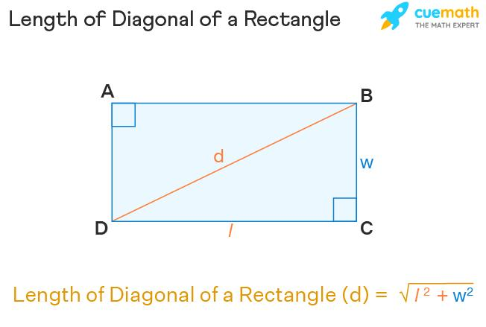
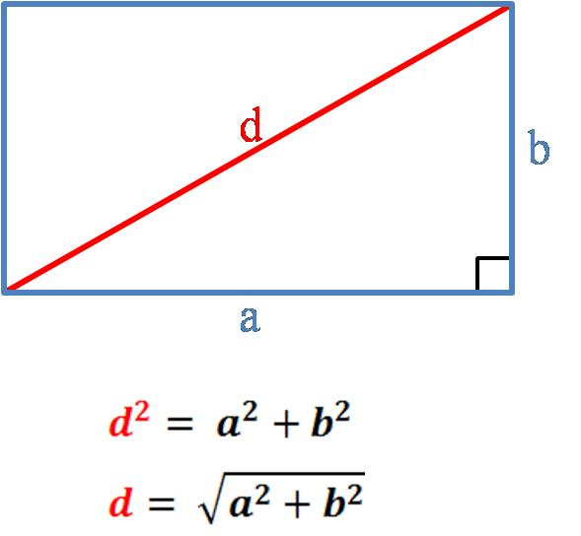
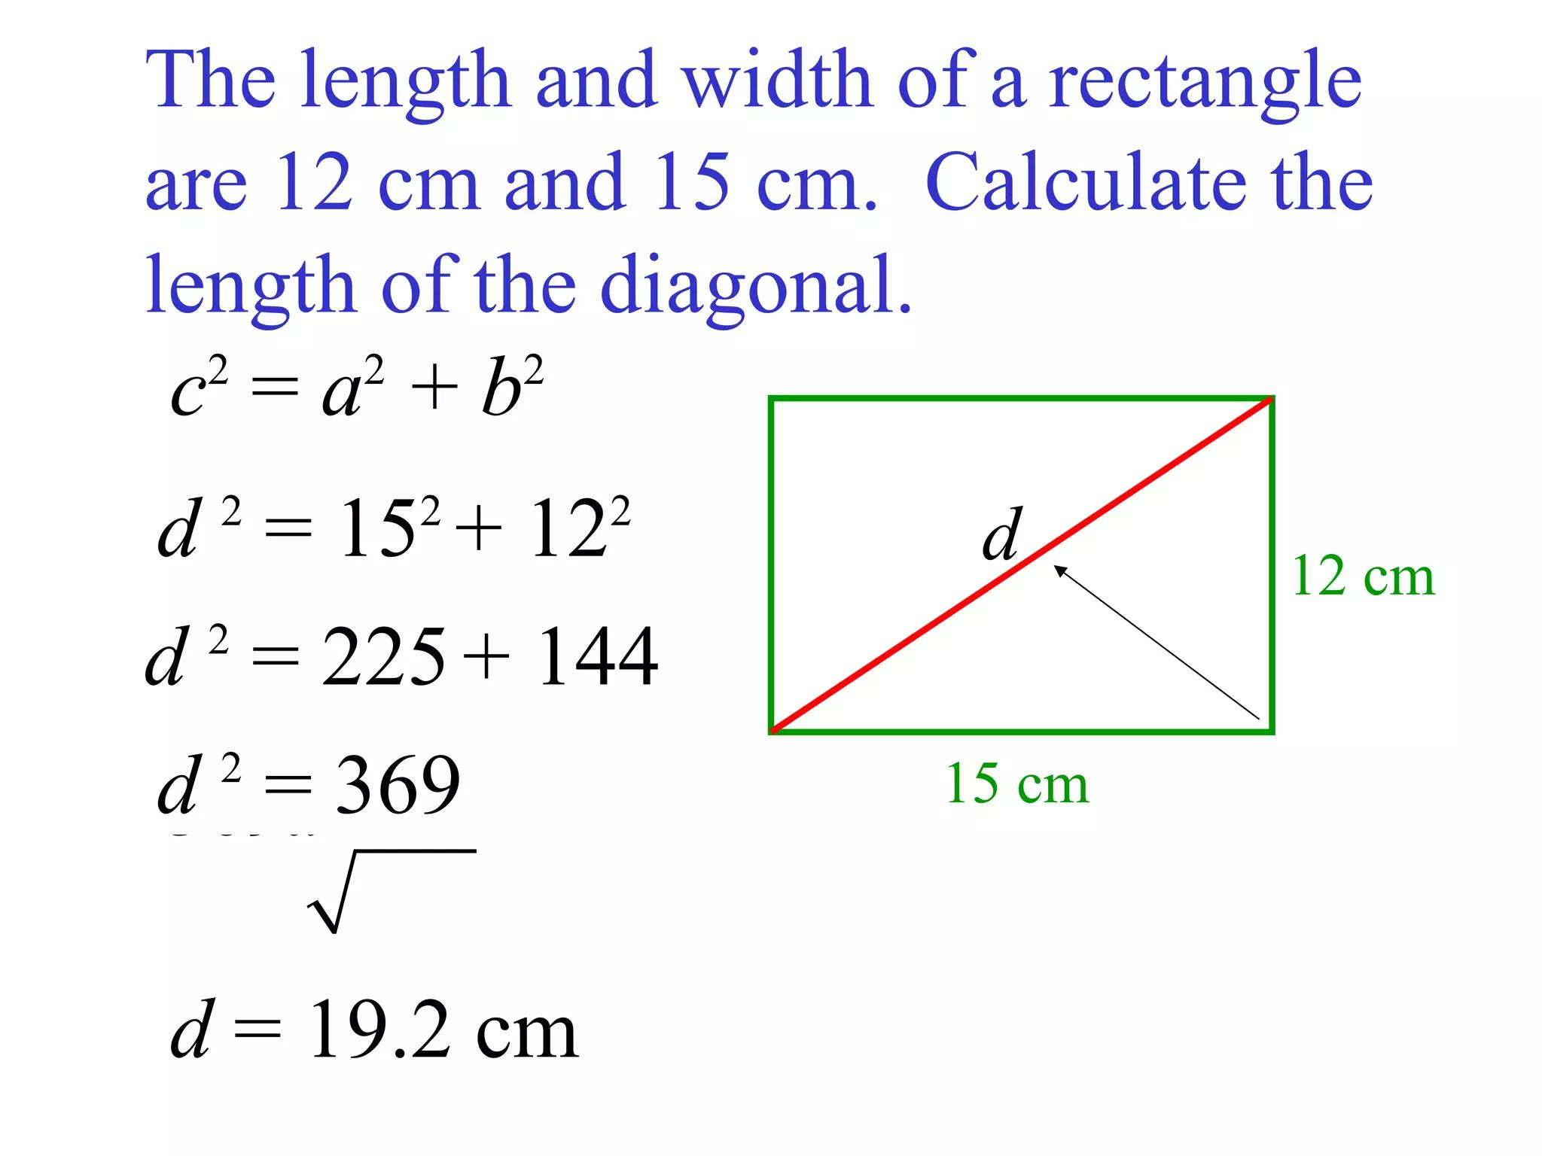
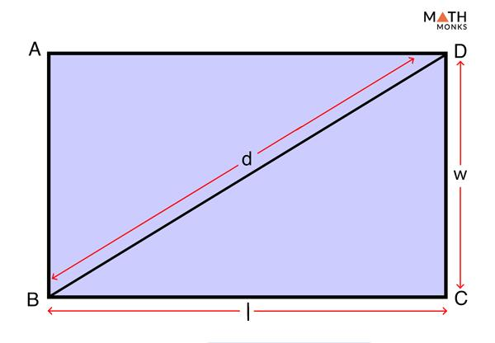

Diagonal of a Square
# Source: AI Source: Provided by: [Data Path: Persons Table -> ID Column: 1, Name_En Column: Motasem Essam] -> From: [ChatGPT] on [7/25/2026]
For a square with side length $s$, the diagonal is:
$$\boxed{d=s\sqrt{2}}$$
because:
$$d^{2}=s^{2}+s^{2} \\ d^{2}=2s^{2}$$
Therefore:
$$\boxed{d=s\sqrt{2}}$$

Distance Between Two Points
# Source: AI Source: Provided by: [Data Path: Persons Table -> ID Column: 1, Name_En Column: Motasem Essam] -> From: [ChatGPT] on [7/25/2026]
The Pythagorean Theorem is the foundation of the distance formula in coordinate geometry.
For:
$$A\left(x_{1} , y_{1}\right)$$
and:
$$B\left(x_{2} , y_{2}\right)$$
the horizontal and vertical differences form the legs of a right triangle.
Therefore:
$$\boxed{d=\sqrt{{\left(x_{2}-x_{1}\right)}^{2}+{\left(y_{2}-y_{1}\right)}^{2}}}$$
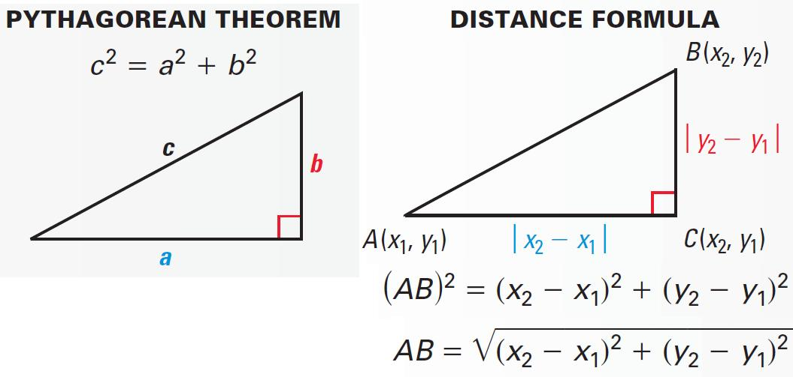
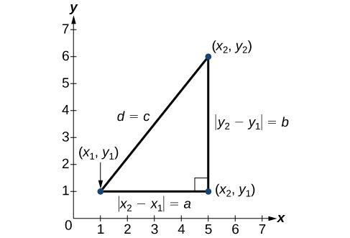
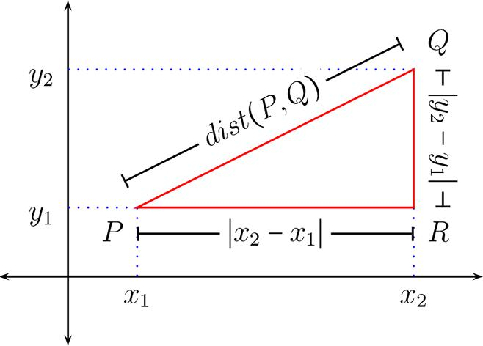
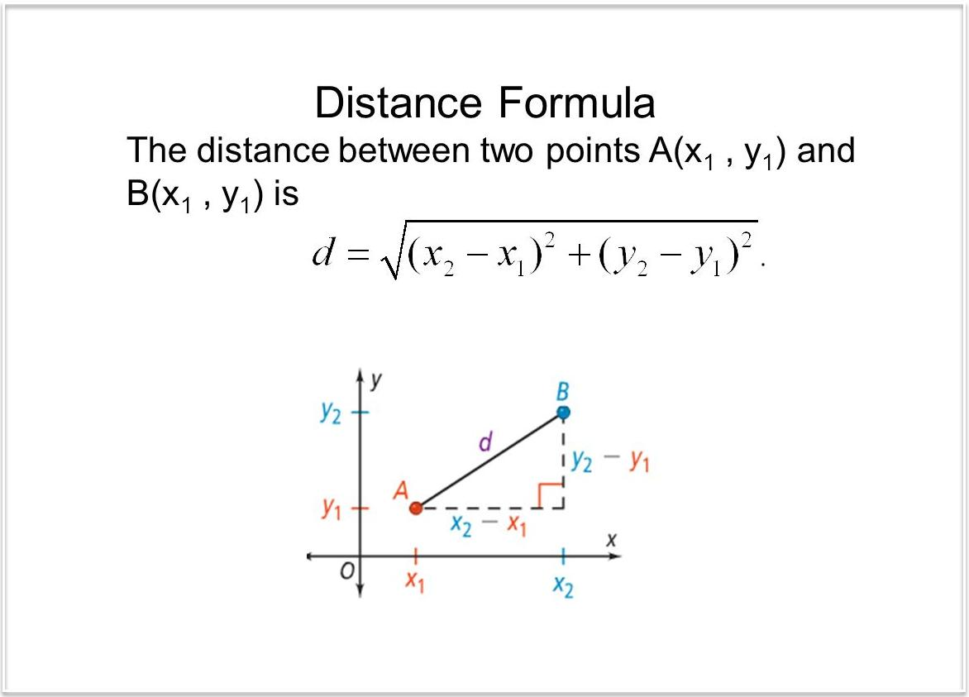
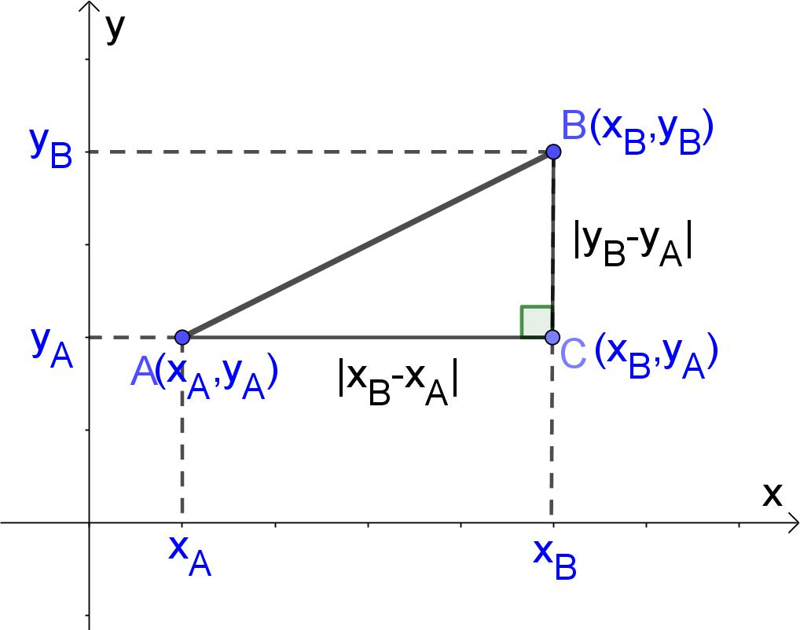

Example — Distance Between Points
# Source: AI Source: Provided by: [Data Path: Persons Table -> ID Column: 1, Name_En Column: Motasem Essam] -> From: [ChatGPT] on [7/25/2026]
Suppose:
$$A=\left(1 , 2\right)$$
and:
$$B=\left(4 , 6\right)$$
Then:
$$d=\sqrt{{\left(4-1\right)}^{2}+{\left(6-2\right)}^{2}} \\ d=\sqrt{3^{2}+4^{2}} \\ d=\sqrt{9+16} \\ \boxed{d=5}$$

Pythagorean Theorem and Similarity
# Source: AI Source: Provided by: [Data Path: Persons Table -> ID Column: 1, Name_En Column: Motasem Essam] -> From: [ChatGPT] on [7/25/2026]
The Pythagorean Theorem is closely related to similar right triangles.
When a right triangle is divided by an altitude from the right angle to the hypotenuse, the resulting smaller triangles are similar to the original triangle.
This produces several additional relationships involving the sides and altitude.
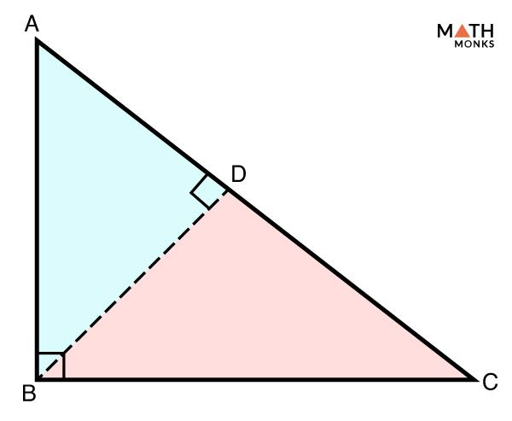
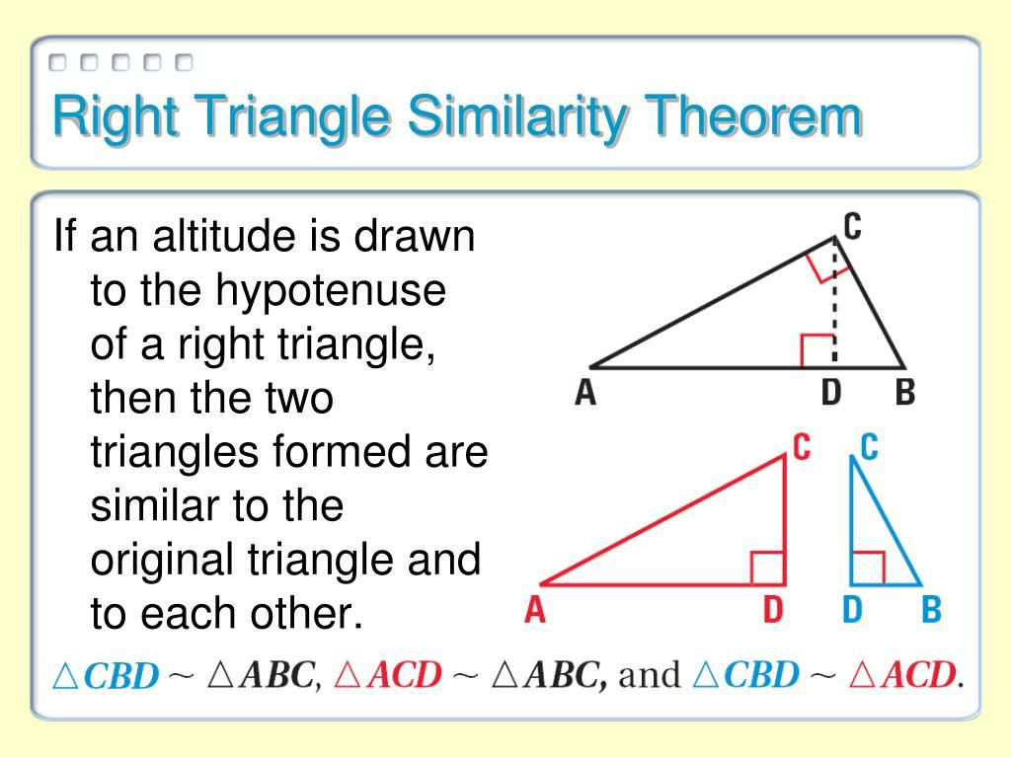
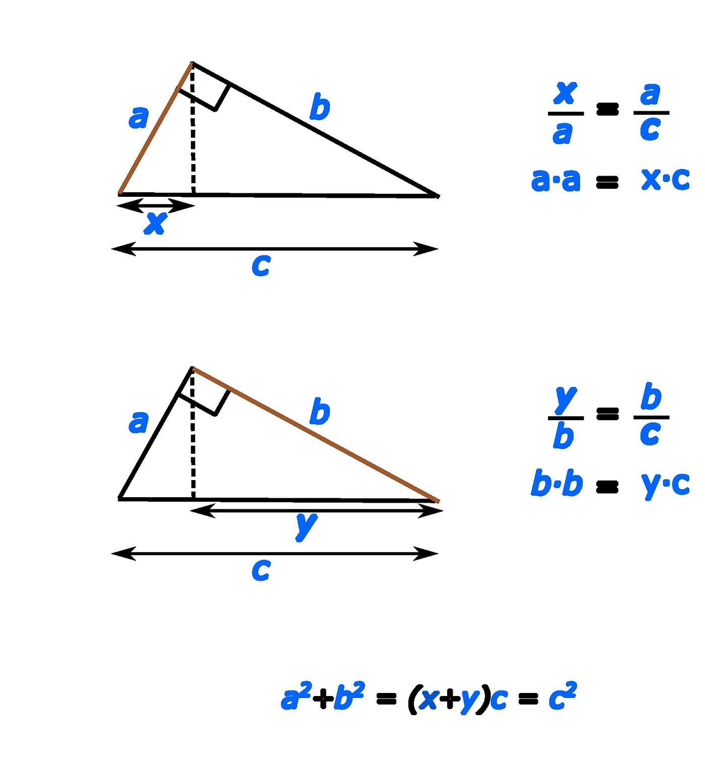
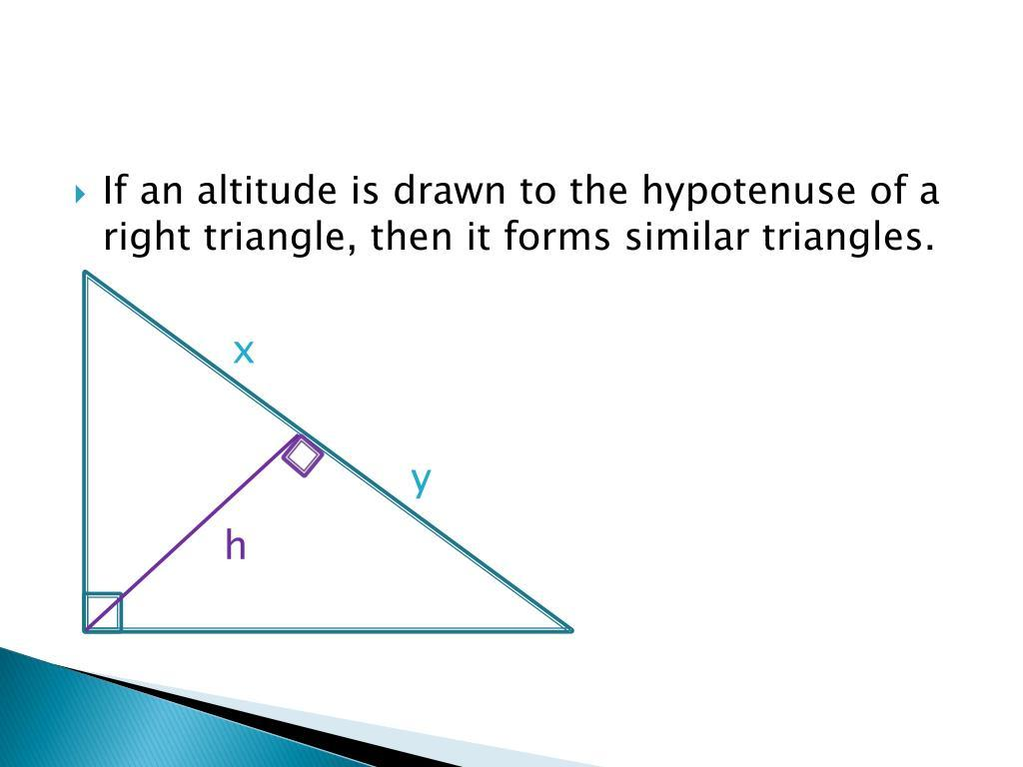
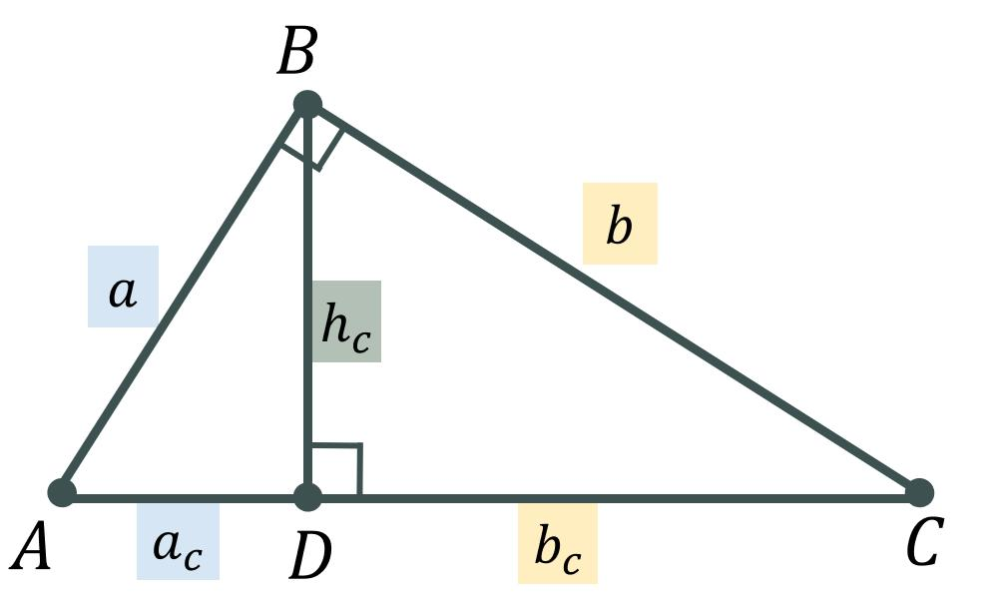

Pythagorean Theorem and Trigonometry
# Source: AI Source: Provided by: [Data Path: Persons Table -> ID Column: 1, Name_En Column: Motasem Essam] -> From: [ChatGPT] on [7/25/2026]
The Pythagorean Theorem is also connected to trigonometry.
For a right triangle:
$$a^{2}+b^{2}=c^{2}$$
Dividing by $c^{2}$:
$$\frac{a^{2}}{c^{2}}+\frac{b^{2}}{c^{2}}=1$$
This leads to the fundamental trigonometric identity:
$$\boxed{\sin^{2}θ+\cos^{2}θ=1}$$

Geometric Interpretation
# Source: AI Source: Provided by: [Data Path: Persons Table -> ID Column: 1, Name_En Column: Motasem Essam] -> From: [ChatGPT] on [7/25/2026]
The theorem can be visualized using squares constructed on the three sides of a right triangle.
The area of the square on the hypotenuse equals the sum of the areas of the squares on the two legs.
Thus:
$$\boxed{a^{2}+b^{2}=c^{2}}$$
because:
$$a^{2}=\text{area of square on }a \\ b^{2}=\text{area of square on }b \\ c^{2}=\text{area of square on }c$$
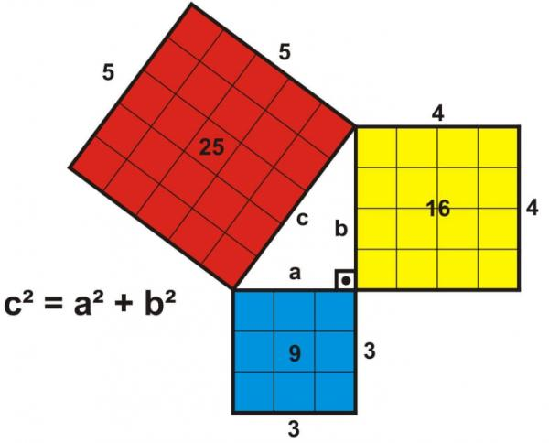
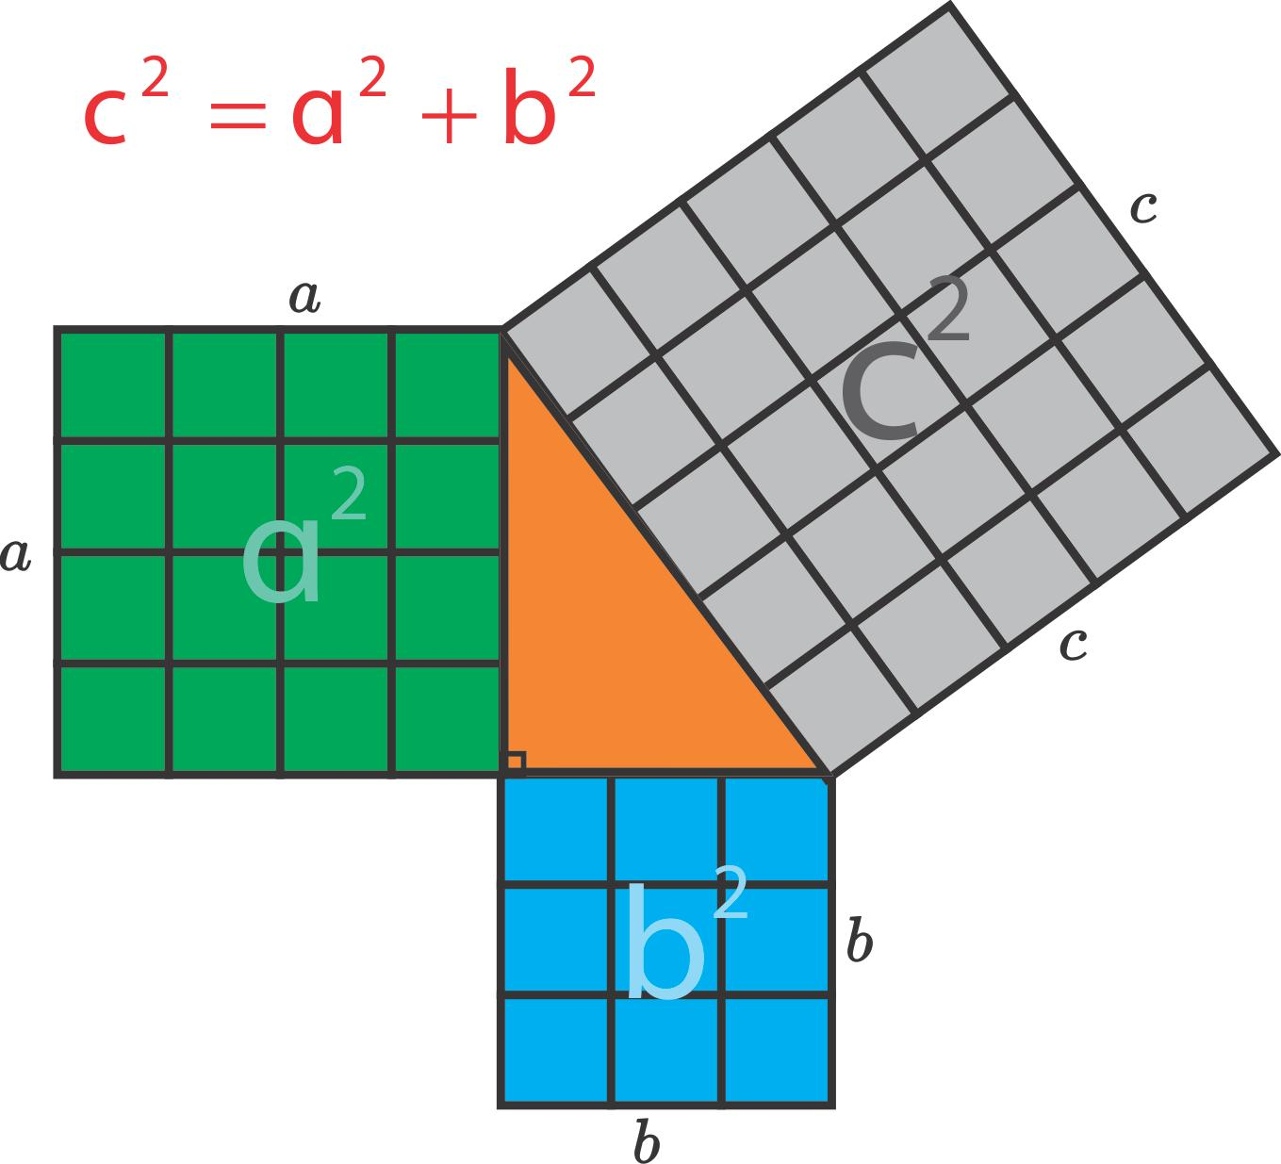

Historical Note
# Source: AI Source: Provided by: [Data Path: Persons Table -> ID Column: 1, Name_En Column: Motasem Essam] -> From: [ChatGPT] on [7/25/2026]
The theorem is named after the ancient Greek mathematician Pythagoras, although relationships equivalent to the theorem were known and used by mathematical civilizations before and around the time of ancient Greece.
The theorem became one of the central results of classical Euclidean geometry.

Real-World Examples
# Source: AI Source: Provided by: [Data Path: Persons Table -> ID Column: 1, Name_En Column: Motasem Essam] -> From: [ChatGPT] on [7/25/2026]
The Pythagorean Theorem is used in:
- Construction.
- Architecture.
- Surveying.
- Engineering.
- Navigation.
- Computer graphics.
- Robotics.
- Physics.
- Land measurement.
- Distance calculations.
For example, construction workers can use it to verify whether a corner is exactly ${90}^{∘}$.
A $3-4-5$triangle is especially useful for checking right angles.
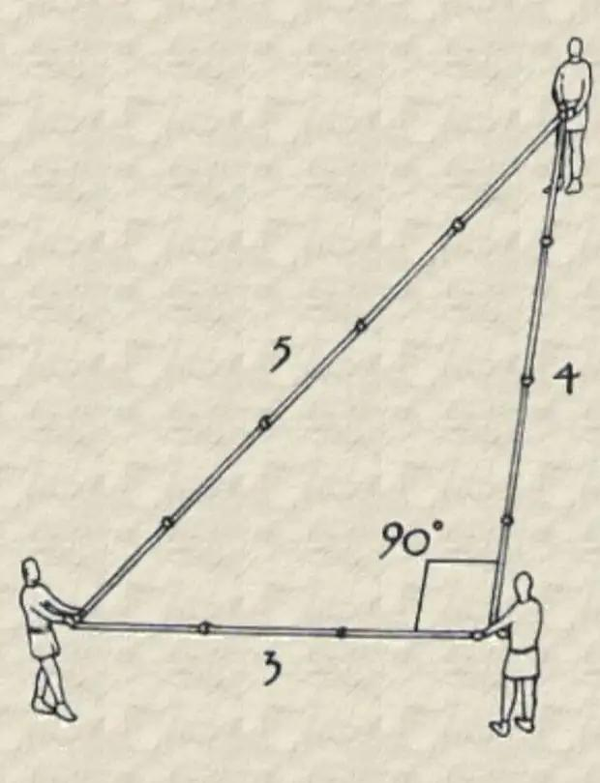
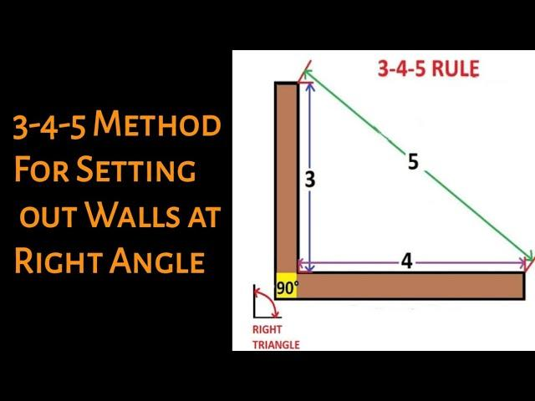
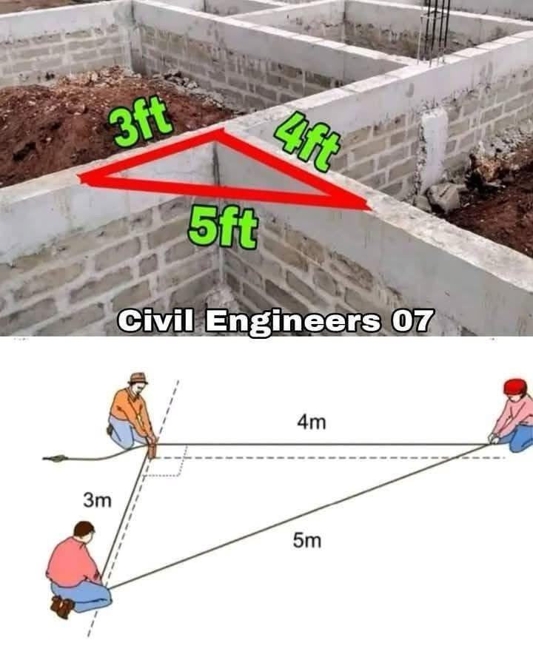
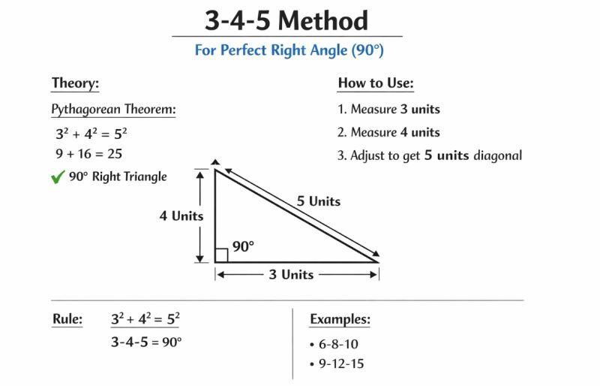
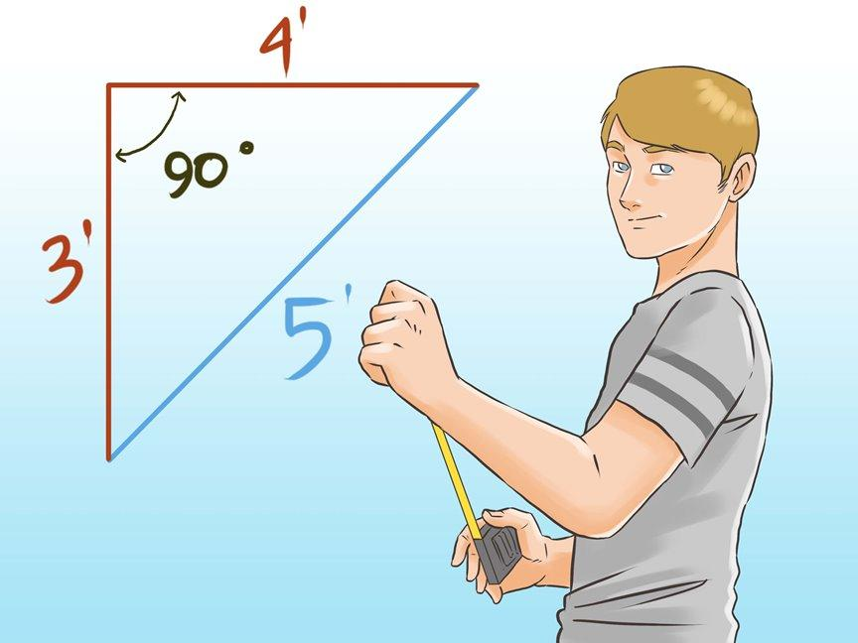

Applications
# Source: AI Source: Provided by: [Data Path: Persons Table -> ID Column: 1, Name_En Column: Motasem Essam] -> From: [ChatGPT] on [7/25/2026]
The Pythagorean Theorem is important in:
- Plane Geometry
- Triangle Geometry
- Coordinate Geometry
- Trigonometry
- Euclidean Geometry
- Surveying
- Architecture
- Civil Engineering
- Mechanical Engineering
- Computer Graphics
- Robotics
- Physics

Advantages
# Source: AI Source: Provided by: [Data Path: Persons Table -> ID Column: 1, Name_En Column: Motasem Essam] -> From: [ChatGPT] on [7/25/2026]
Studying the Pythagorean Theorem helps to:
- Find unknown side lengths.
- Calculate diagonal lengths.
- Calculate distances.
- Identify right triangles.
- Solve coordinate geometry problems.
- Understand trigonometric relationships.
- Solve practical measurement problems.
- Support engineering and architectural calculations.

Limitations
# Source: AI Source: Provided by: [Data Path: Persons Table -> ID Column: 1, Name_En Column: Motasem Essam] -> From: [ChatGPT] on [7/25/2026]
The Pythagorean Theorem:
- Applies directly only to right triangles.
- Requires identifying the hypotenuse correctly.
- Cannot be used directly as $a^{2}+b^{2}=c^{2}$for arbitrary non-right triangles.
- Requires consistent units for the side lengths.
- Does not by itself determine every property of a triangle.
For non-right triangles, other tools such as the Law of Cosines may be required.

Comparison with Related Concepts
# Source: AI Source: Provided by: [Data Path: Persons Table -> ID Column: 1, Name_En Column: Motasem Essam] -> From: [ChatGPT] on [7/25/2026]
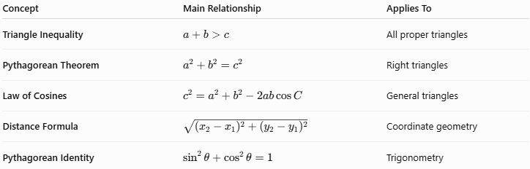
Concept | Main Relationship | Applies To
Triangle Inequality | $$a+b>c$$ | All proper triangles
Pythagorean Theorem | $$a^{2}+b^{2}=c^{2}$$ | Right triangles
Law of Cosines | $$c^{2}=a^{2}+b^{2}-2ab\cos{C}$$ | General triangles
Distance Formula | $$\sqrt{{\left(x_{2}-x_{1}\right)}^{2}+{\left(y_{2}-y_{1}\right)}^{2}}$$ | Coordinate geometry
Pythagorean Identity | $$\sin^{2}θ+\cos^{2}θ=1$$ | Trigonometry

Key Points
# Source: AI Source: Provided by: [Data Path: Persons Table -> ID Column: 1, Name_En Column: Motasem Essam] -> From: [ChatGPT] on [7/25/2026]
- The Pythagorean Theorem applies to right triangles.
- Its fundamental formula is:
$$\boxed{a^{2}+b^{2}=c^{2}}$$
- $a$and $b$are the legs.
- $c$is the hypotenuse.
- The hypotenuse is opposite the ${90}^{∘}$ angle.
- The hypotenuse is always the longest side.
- To find the hypotenuse:
$$\boxed{c=\sqrt{a^{2}+b^{2}}}$$
- To find a leg:
$$\boxed{a=\sqrt{c^{2}-b^{2}}}$$
- The converse can determine whether a triangle is right.
- The theorem is fundamental to the distance formula.
- It is closely related to similarity and trigonometry.
- Common Pythagorean triples include:
$$\boxed{3-4-5, 5-12-13, 8-15-17}$$

Conclusion
# Source: AI Source: Provided by: [Data Path: Persons Table -> ID Column: 1, Name_En Column: Motasem Essam] -> From: [ChatGPT] on [7/25/2026]
The Pythagorean Theorem is one of the fundamental theorems of plane geometry. It establishes the relationship between the three side lengths of a right triangle:
$$\boxed{a^{2}+b^{2}=c^{2}}$$
where $a$ and $b$ are the legs and $c$ is the hypotenuse.
The theorem can be used to find unknown sides, calculate diagonals, determine distances between points, and identify right triangles. It also forms an important connection between plane geometry, coordinate geometry, similarity, and trigonometry.
Because of its wide range of applications in construction, architecture, engineering, surveying, computer graphics, robotics, and physics, the Pythagorean Theorem is one of the most important mathematical relationships in geometry.

